**Leader Overview**



**Volume Overview**

**Who is Jesus?**

*In the classic book* Mere Christianity*, C. S. Lewis reasoned that those who refuse to believe Jesus’ claim to be God are left with the option of labeling Him as a lunatic or the devil. Jesus asked His closest followers who people thought He was (*[*Matthew 16:13*](https://ref.ly/logosref/Bible.Mt16.13)*). The disciples responded with far-ranging opinions. But then Jesus turned the question on them: “Who do you say I am?” Two thousand years later, there may not be a more important question for any of us to answer*.

**Session Overview**

**Jesus Is the Perfect Sacrifice**

*In this* **Learn** *session, preschoolers discover that everyone in the world is loved by God. Jesus came to show us that He was the perfect One to come to this world to save everyone. While* death *and* sacrifice *are big words for preschoolers to grasp, they can understand that Jesus hurt for them. The amazing fact that Jesus is now alive should always be shared alongside the Bible story of Jesus on the Cross*.

**Bible Lesson**

Jesus’ Death on the Cross

[John 19:1–6](https://ref.ly/logosref/Bible.Jn19.1-6), [16–19](https://ref.ly/logosref/Bible.Jn19.16-19), [28–30](https://ref.ly/logosref/Bible.Jn19.28-30)

**Faith Fact**

Jesus loves the world.

**Faith Verse**

[John 3:16](https://ref.ly/logosref/Bible.Jn3.16) (NLT)

“For this is how God loved the world: He gave his one and only Son, so that everyone who believes in him will not perish but have eternal life.”

**Preparing for the Session**

**Leader Preparation Time: 20–25 Minutes**

|  |
| --- |
| ***You Will Need***  ***Preservice Activities***  *•* ***Preservice Activities Pages 1*** *and* ***2***  *• Play dough*  *• Heart-shaped cookies, one per kid*  *• Optional: White or pink frosting*  *• Optional: Craft sticks or plastic knives, one per kid*  ***Large Group***  *• Bible*  *•* ***Preservice Activities Pages 1*** *and* ***2***  *• Worship songs (Song suggestions: “Praise the Lord Every Day” by Yancy, “Hosanna” by Yancy; “Jesus Loves Me All the Time” by Singin’ Praise Kids)*  *• For groups not using a phone or tablet only, add:*  *• Projector or TV*  *• Laptop*  *•* ***Faith Fact Sound video*** *(bell ringing)*  *•* ***Faith Fact Slide***  *•* ***Faith Verse Slide***  *•* ***Bible Lesson Video A***  *•* ***Bible Lesson Video B***  ***Small Group***  *•* ***Small Group Group Connection Page****, one per group*  *• Heart-shaped or small dot stickers*  *•* ***Small Group Activity Page****, one per kid*  *• Watercolor paint and brushes*  *• Plastic tablecloths*  *• Bowls of water*  *•* ***Hands-On Learning Page****, one for every four groups*  *• Clear drinking glass or vase*  *• Small zipper plastic bags, one per group*  *• Black markers. one per group*  *• Scissors*  *• Markers*  *• Water*  *To access session content and videos from a computer, visit:* [*BibleEngagementProject.com/downloads*](https://bibleengagementproject.com/Downloads) |
| ***Getting Ready***  ***Preservice Activities***  *• Set out toys and snacks.*  *• Print the* ***Preservice Activities Pages 1*** *and* ***2.***  ***Large Group***  *• Download videos and slides if needed.*  *• Select worship song(s) and have them ready to play.*  ***Small Group***  *• Print the* ***Small Group Group Connection Page****, one per group.*  *• Print copies of the* ***Small Group Activity Page****, one per kid.*  *• Cover the tables with the plastic tablecloths.*  *• Print the* ***Hands-On Learning Page****, one for every four groups.*  *• Cut out the pictures.*  *• Fill the vases or glasses with water to the top.*  *• Practice this illusion to make sure it will work with your items.*  *First time leading* Learn *for Preschool? Check out the* [Facilitator Guide](https://0b769b0ed3569ef9d18b-f88d8272f61086866d50d048b43ef630.ssl.cf2.rackcdn.com/sites/biblengagementproject/Listen_Facilitator_Guide.pdf). |

**Preservice Activities**

*See what’s needed at the beginning of the session.*

**Bible Story Warm-Up**

Today, our Bible story is about Jesus. We’ll look for two different shapes as we learn about Him today. Let’s see if you can tell me what they are.

• *Hold up the* ***Preservice Activities Pages****. Have kids name the shapes*.

Later, we’ll find out how a heart and a cross tell us about Jesus. Let’s see if we can make these shapes with our play dough

• *Display pictures so kids can mirror the shape with their play dough*.

• *Ask these questions.*

What does a heart mean?

When we see a cross, whom should we think about?

Was it easier for you to make a heart or a cross?

**Snack**

**Heart-Shaped Cookies**

Our Faith Verse tells us that God showed love to the world. That means He loves everyone, including you and me. What shape reminds you of love? *(Group response)* Let’s enjoy these cookies together.

• *Optional: Provide frosting and let kids decorate the cookies*.

• *As kids are eating the snack, share the following:*

Who loves you a lot? Let’s name as many people as we can. *(Allow responses.)* Who do you love a lot? *(Allow responses.)* I wonder how much love it takes for God to love everyone in the whole world. What do you think? *(Allow responses.)*

**Free Play**

*Any extra time can be spent playing with toys*.

**Transition**

*A few minutes before service begins have kids make their way to the large group area and sit in their designated areas*.

**Large Group**

**25 Minutes**

*See what’s needed at the beginning of the session.*

**Introduction**

Welcome, kids! This is the part of our time together where we get to learn from God’s Word, the Bible. *(Hold up a Bible.)* The Bible tells us about Jesus. We’ll learn how He showed us that He loves us. Show me with your hands and arms how much you think Jesus loves you. If Jesus loves you just a little, put your hands close together. If He loves you a whole lot, stretch your hands far apart. Ready to show me? Go! *(Group response)*

• *Stretch your arms with your hands far apart*.

I know Jesus loves me a lot! There are two shapes that we’re going to watch for today. What are they?

• *Hold up the* ***Preservice Activities Pages 1*** *and* ***2****, one at a time*.

I think they go with our Bible story today. Let’s watch for them and see if we can figure out how.

**Faith Fact**

Our Faith Fact today is about love. I think we already have a match with one of our shapes. Which one is it? *(Allow responses.)* You’re right! Love goes with the heart.

• *Show the* ***Faith Fact Slide***.



Let’s hug ourselves close while we say our Faith Fact. Ready? **Jesus loves the world.** Can you whisper it? **Jesus loves the world.** Can you shout it? **Jesus loves the world.** Great job!

**Bible Time**

Speaking of loving the world, our Faith Verse is about that, too. We’ve got someone special to help us learn it. Let’s see what Lizzy is doing.

• *Play* ***Bible Lesson Video A***.

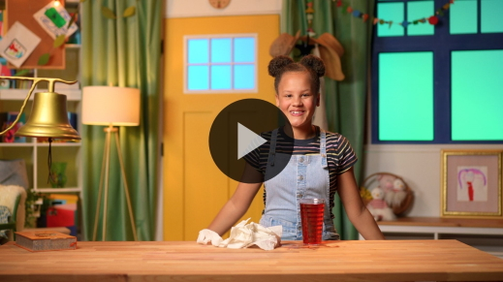

Great job practicing the Faith Verse! We’re learning all of it together. It’s such a great reminder of how much Jesus loves us.

**Worship**

Hey! Love reminds me of one of our shapes again. Which one is it? *(Group response)* The heart is for love. Who loves us more than anyone? *(Group response)* God does. Let’s worship Him now.

**Praise**

Are you glad God loves you? Wave your hands up high. *(Group response)*

Are you glad Jesus loves you? Spread your arms out wide. *(Group response)*

Who wants to tell God thank You? Wave your hands up high again. *(Group response)*

**Sing**

Now let’s worship God by singing to Him.

• *Lead the kids in singing one or two songs. See song suggestions at the beginning of the session*.

**Prayer**

God loves us so much. Let’s bow our heads and pray.

|  |
| --- |
| Dear God, thank You for loving everyone in the world. Thank You for loving us. We love You, too. Amen. |

**Bible Time cont’d**

Thanks for praying with me. Now, let’s see. We’ve figured out what the heart is for. Let’s look at the other shape again. What is it? *(Group response)*

• *Hold up the* ***Preservice Activities Page 1****, the cross picture*.

I wonder if we’ll find out about this shape in our Bible story. It’s time to visit with Grandpa and Lizzy and listen to what they can tell us about Jesus.

• *Play* ***Bible Lesson Video B***.

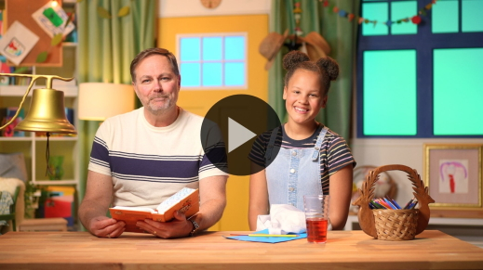

Wow, friends! I think we found another one of our shapes, didn’t we? *(Group response)*

• *Hold up the* ***Preservice Activities Page 1****, the cross page*.

Grandpa and Lizzy wanted us to know about Jesus and the Cross. It could be a sad story, but instead it shows us how much Jesus loves us. That goes with our other shape.

• *Hold up the* ***Preservice Activities Page 2****, the heart page*.

Jesus really showed how much He loved everyone in our Bible story today.

**Response Time**

• *Play a worship song quietly*.

Jesus was on the Cross. It hurt Jesus, but He did this because He loves the world and loves us. Let’s show Jesus our appreciation for what He did for us. Put your hands over your heart. *(Pause for kids to respond.)* Now let’s pray.

• *Have the kids repeat phrases of the prayer after you*.

|  |
| --- |
| Dear Jesus, thank You for the Cross. Thank You for loving us so much. Thank You, Jesus, for loving the world. Amen. |

**Faith Verse**

Did you know God loves it when we learn Bible verses from His Word? Let’s say our Faith Verse and do the actions together.

• *Show the* ***Faith Verse Slide***.

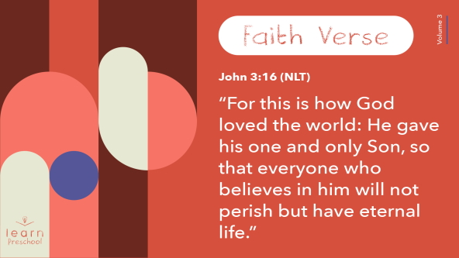

[John 3:16](https://ref.ly/logosref/Bible.Jn3.16) (NLT)

“For this is how God loved the world: He gave his one and only Son, so that everyone who believes in him will not perish but have eternal life.”

**John** *(hands at waist, spread apart, palms up and out)*

**3:** *(hands together like a clap)*

**16** *(hands opened to “book”)*

**“For this is how God** *(two index fingers point up)*

**loved the world:** *(two hands covering heart)*

**He gave his one and only Son**, *(hold up one finger)*

**so that everyone who believes in him** *(palms up, move hands away from body and out)*

**will not perish** *(make fists, bend elbows, and cross arms as they go down and away from body)*

**but have eternal life.”** *(make L with index fingers and thumbs and move arms up sides of body)*

You’re so awesome! You’re doing such a good job learning our Faith Verse!

**Closing**

Did you learn more about Jesus today? *(Group response)* We’ve worshipped Him by singing and praying. We’ve learned a Faith Verse from the Bible.

• *Hold up the* ***Preservice Activities Pages 1*** *and* ***2***.

Most importantly, we discovered that Jesus loves us because He was willing to be on the Cross for us. That’s just what our Faith Fact tells us.

• *Play the* ***Faith Fact Sound*** *video (bell ringing)*.

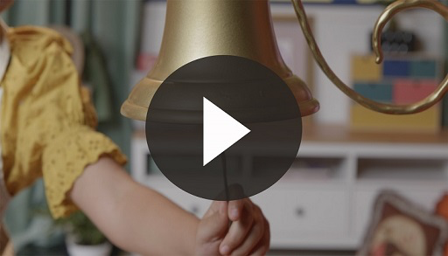

Hey! That sound means it’s time to say our Faith Fact one more time. **Jesus loves the world**.

• *Show the* ***Faith Fact Slide***.



Here we go! **Jesus loves the world.** Raise your hands and let’s tell Jesus thank You. Thank You, Jesus, for loving the world. *(Group response)*

**Dismissal to Small Groups**

It’s time to go to our circles where we’ll spend time in our very special small groups.

• *Dismiss the kids by groups.*

|  |
| --- |
| ***Leader Tip:*** *This can be done by assigning color teams or by age groups. Note that some young preschoolers may not know their age. Using a colored sticker, jersey, or wristband will help separate the kids and help identify their small groups.* |

**Small Group**

**25 Minutes**

*See supplies and prep instructions at beginning of session or in each activity below.*

|  |
| --- |
| ***Leader Tip:*** *Small groups can alternate to each circle, or all groups can do each activity at the same time. If you choose to alternate, you will need at least one leader per circle.* |

**Circle 1**

**Group Connection**

**Jesus Loves the World**

|  |
| --- |
| ***You Will Need***  *•* ***Small Group Group Connection Page****, one per group*  *• Heart-shaped or small dot stickers*  ***Getting Ready***  *• Print the* ***Small Group Group Connection Page****, one per group.* |

What’s our Faith Fact today? **Jesus loves the world.** He loves all of us so much.

• *Hold up the* ***Group Connection Page***.

This is a map of the world. It says, “Jesus loves the world.” We know Jesus loves us, so let’s put a sticker where we are on the map.

• *Add a sticker to your approximate location*.

People live all over our world. Jesus loves all the people who live in those places, too. Let’s take these stickers and place them anywhere on the map. When you put a sticker on the map, say, “Jesus loves you.”

• *Give a sticker to each kid*.

Everywhere we put the stickers is a place where Jesus loves the people who live there. But, the people who live there might not know that Jesus loves them. Let’s pray for all the people of the world to know that Jesus loves them.

• *Have the kids lay their hands on the map as you pray*.

|  |
| --- |
| Dear Jesus, help the people of the world know that You love them very, very much. Amen. |

**Circle 2**

**Activity Page Time**

**Cross in a Heart**

|  |
| --- |
| ***You Will Need***  *•* ***Small Group Activity Page****, one per kid*  *• Watercolor paint and brushes*  *• Plastic tablecloths*  *• Bowls of water*  ***Getting Ready***  *• Print copies of the* ***Small Group Activity Page****, one per kid.*  *• Cover the tables with the plastic tablecloths.* |

Today, we’ve been watching for two special shapes. What are they? *(Allow responses.)* Jesus showed how much He loves us by going to the Cross, didn’t He? *(Group response)*

• *Hand out the* ***Small Group Activity Page***.

• *Point at the cross and then the heart*.

The heart shows how much Jesus loves us. That’s why the cross is inside the heart. It reminds us that Jesus loves us so much that He chose to be hurt on the Cross for us. Let’s paint our two special shapes.

• *As kids are painting, ask these questions:*

How does Jesus show His love for us?

How does Jesus’ love make you feel?

• *During the activity, interrupt and practice the Faith Fact:* **Jesus loves the world**.

• *Play* ***Faith Fact Sound*** *video. Review the Faith Fact even if you can’t play the sound*.



**Circle 3**

**Feet-to-Floor Game Time**

**Love around the World**

Who wants to play a game? *(Group response)* We’ve talked about two shapes today. What are they? *(Allow responses.)* We’ll sit in a circle, and one of you will be “It.” When you’re “It,” you’ll go around the outside of the circle and lightly tap each friend’s shoulder or head as you say, “Heart.”

Then, choose someone to tap and say, “Jesus loves you!” That person will stand up, chase you around the circle, and try to tag you before you make it back around to their spot. If they tag you, they’ll say, “Jesus loves you.” Then, they get to be “It.” Who’s ready to play? *(Group response)*

• *Make sure the kids don’t tap their friends too hard*.

• *Play until everyone has had a chance to be “It” if you have time*.

**Circle 4**

**Hands-On Learning**

**Wash Away Sin**

|  |
| --- |
| ***You Will Need***  *•* ***Hands-On Learning Page****, one for every four groups*  *• Clear drinking glass or vase*  *• Small zipper plastic bags, one per group*  *• Black markers. one per group*  *• Scissors*  *• Markers*  *• Water*  ***Getting Ready***  *• Print the* ***Hands-On Learning Page****, one for every four groups.*  *• Cut out the pictures.*  *• Fill the vases or glasses with water to the top.*  *• Practice this illusion to make sure it will work with your items.* |

Being on the Cross hurt Jesus very much, but He chose to be on the Cross because He loves the world. He loves you and me.

• *Show kids the paper with SIN on it*.

No matter how hard we try, we can’t be perfect. When we do things that hurt Jesus, that’s called sin. Sin keeps us from being close to Jesus. What are some things we do that we shouldn’t do? *(Allow responses.)*

• *Use markers to scribble on the paper as kids name things*.

My paper doesn’t look very nice when I scribble all over it and mess it up. That’s why Jesus was on the Cross.

• *Put the paper in the plastic bag and seal it*.

• *Trace an outline of the cross with a black marker on the outside of the bag*.

• *Make sure the paper is pressed against the cross image*.

Jesus went to the Cross to take away the wrong things we have done. The Cross is special.

• *Take the bag and slide it in the glass of water*.

• *Hold up the glass for kids to see the paper from the side. They should see the scribbles and the cross outline*.

When we look at our sin, what do you see? *(Allow responses.)* We see the things we’ve done to hurt Jesus. But God doesn’t look at us like we do. God looks down and sees something different. Let’s look at our picture from the top.

• *Have kids look into the glass from the top. If the paper is pressed against the bag, the scribbles should disappear and only the cross can be seen*.

Now what do you see? *(Allow responses.)* Where are the sins? Where is the yucky stuff that keeps us from being close to God? Do you see it? *(Group response)*

That’s because of Jesus. He was the perfect One to take away our sin. Our Faith Fact tells us why He did that. Let’s say it now. **Jesus loves the world**.

**Dismissal**

• *Play* ***Faith Fact Sound*** *video (bell ringing).*



• *Show the* ***Faith Fact Slide***.



Before we go, let’s say the Faith Fact together one last time. **Jesus loves the world**. Wonderful! I had a great time learning more about Jesus with you. See you next time!

• *Send home the* ***Small Group Activity Page*** *with each kid*.

• *Remind parents that there are* ***Family Devotions*** *available on the app to do with their kid*.

• *Tell everyone the date and time for the next session*.